EPSi Budget Manager: Training Guide Enterprise Budget Manager

- Launch EPSi
- Go to My Virtual Workplace (Centura Portal)
- Select Work Tools > Non-Clinical Tools > EPSi

Your user name and password is your Centura network id and password.

Enterprise Budget Manager Navigation
To access the Application Launcher, click on the Applications icon and the list of web applications will appear.

Budget Manager Navigation

To begin working on budget tasks within Enterprise Budget Manager, select “Budget Manager” from the “Application Launcher” dropdown list. The application list will also include any other modules in EBM that you have security access to.

If you have access to multiple facilities, you must first select from the list of facilities within Enterprise Budget Manager. This is accomplished by clicking on the ‘+’ located next to the name of the facility. The tree view will expand to show all of the cost centers you have security access to.

Click on the ‘+’ to expand the tree view. A list of cost centers you have access to will appear.

Click on the cost center you want to begin working on to access the Budget Menu.

Click on the cost center you want to begin budgeting.

The Budget Menu will display with the name of the facility and cost center in blue in the upper left corner of the screen. To return to the facility listing, click on the blue link and start the selection process over.

Click on “Previous” or “Next” to go to another cost center.
Click on the tabs to access the various sections on the Budget Menu.
Click on the blue link to return to the Facility and Cost Center list.

NOTE:
- It is important to note that your access to Cost Centers within Enterprise Budget Manager is controlled through a separate Security module administered by your Budget Manager. You will only see cost centers for which you have budget responsibilities. If you do not have access to the appropriate Cost Centers, or see Cost Centers listed that you should not have access to, please notify Keith Humble and Drew Meifert.

- Editable fields within Enterprise Budget Manager appear in yellow. Information within any yellow field may be changed. After making changes within any form, it is important to click the red button to ensure all changes have been saved. If you neglect to click the save button after making changes, a dialogue box warning will display making you aware you will lose your changes: To save the changes, it is important to click ‘OK.’ To cancel ALL changes made on the form that was being edited, click ‘Cancel.’

- The button appears on many screens throughout the Enterprise Budget Manager application. Clicking the ‘Print’ button will allow you to print the data displayed on the screen.
- From time to time, messages may be sent within the Enterprise Budget Manager system. Some messages are broadcasted as alerts, in which case the message will appear on your screen. When messages are sent without the ‘Alert’ status, you will be notified you have received a new message in the upper right corner of the screen, next to the message icon: Clicking on the icon will display the ‘Messages’ window containing a list of all messages that have been sent to you.

General Ledger Accounts
General Ledger Accounts

Selecting an Account to Budget:

- Begin by selecting the cost center you wish to budget from the appropriate node of the tree view.

- Click on the ‘Budget’ tab of the application located at the top of the screen.
- Select ‘Statistics,’ ‘Expenses,’ ‘Revenues,’ or ‘Deductions’ from the Budget menu to budget the account.
  - For hospital departments the statistic and revenue fields will not be editable. Contact Keith Humble to make adjustments.
- Next, find the account within the grid you wish to budget. In the example below, the ‘Expenses’ option was selected from the ‘Budget’ menu resulting in the following screen:
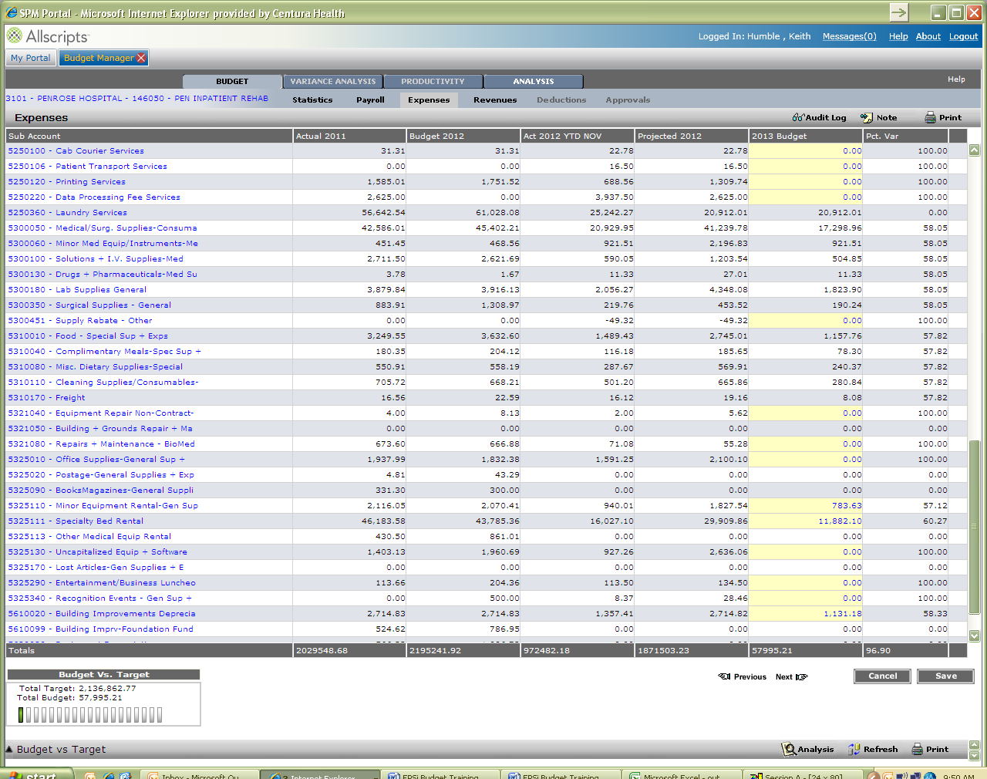

- All editable fields with current year history appear in yellow. A new annual value for the selected account should be input directly on this form.
- You may click on the account you wish to edit to display additional information.
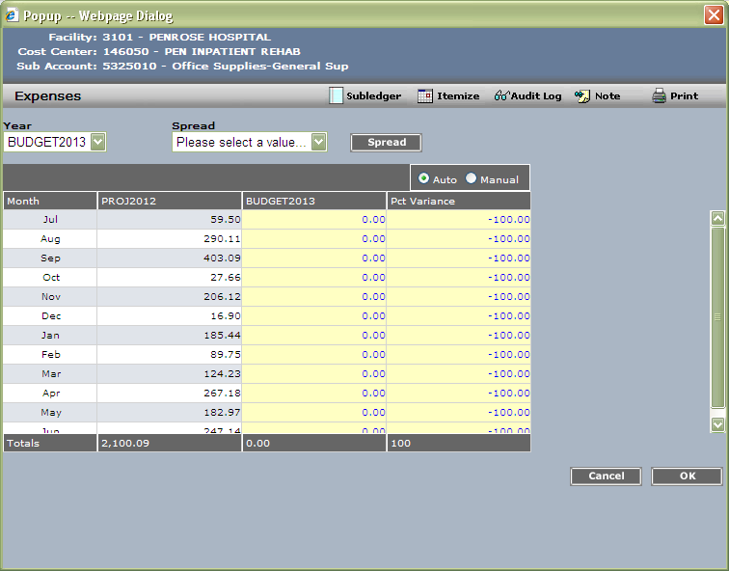

The Accounts Payable Subledger is accessible by clicking on the Subledger icon. This will allow you to see the different vendors paid in the account selected before.
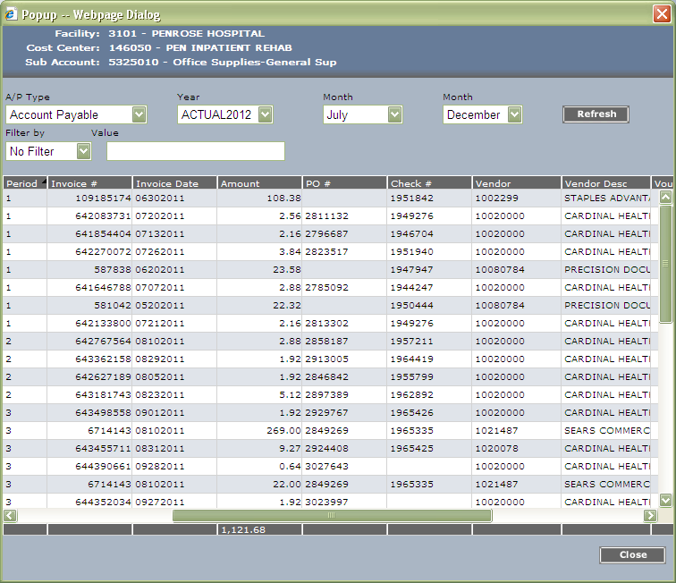

Select applicable year and months from the dropdowns and click Refresh.

NOTE: the years in the system will be different than the years listed on this document. The years you will see in EPSi are:

Actual 2012: actual data from FY 2012 (July – June).
Roll 12 Mos Act: this is a rolling 12 months of data, based on the last complete month being the last month of this “year”.
Budget 2013: data for FY2013 budget year.
Projection 2013: this is combination of Actual FY2013 data for months July – November, and Budget 2013 data for months Dec – June.
2014 Budget: data for FY2014 Budget year.

You can view the invoice through Image Now by clicking on the blue hyperlink under the Document Location column.

- The following accounts are not editable: All salary and contract labor accounts: these accounts will populate based on your input in the payroll menu.
- All benefit accounts: these accounts will be a calculation based on the salary accounts.
- Physician fees: this will be uploaded based on the physician contracts.
- Supply accounts: should flex with volumes. Please review these accounts and notify Finance Staff for changes.
- Depreciation: this will be uploaded based on the accounting fixed asset system.

- Note: When you see next to a sub account, you can click on this icon to see what notes have been entered in regards to this account.
- To view the next cost center, select the button or to go back, select the button.

Entering a Note
Clicking the ‘Note’ icon allows you to enter a justification for the sub account you are budgeting. In certain cases, you may be required to enter a note if the number you have entered result in a variance greater than a pre-determined threshold. Clicking the ‘Note’ icon will bring up the following screen:
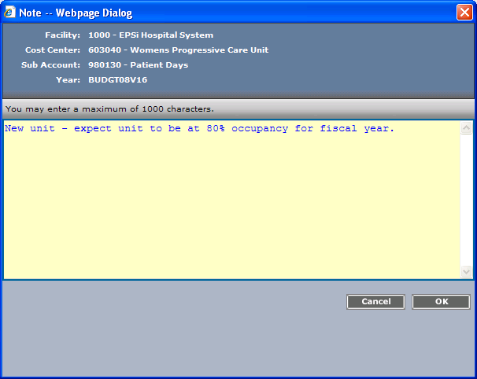
- Click in the ‘Note’ area of the dialog box and enter the note text.
Click on the ‘OK’ button to save your note and return to the account edit window.

