EP17-3 MCj03112480000[1]  **EDM Intervention Changes**

**Updates 4 Oct, 2011**

**Height Added To All Screens with Weight**

**Interventions affected are:**

ED Ambulance Triage Assessment

ED Pediatric Ambulance Triage

ED Triage Assessment

ED Pediatric Triage Assessment

Patient Weight & Height (Order)

ED BURN Infant 0-1 Y/O

ED BURN Toddler 1-4 Y/O

ED BURN Child 5-9 Y/O

ED BURN Adolescent 10 - 14 Y/O

ED BURN Adolescent 15 Y/O

ED BURN Adult 16^ Adult

ED Code Blue Record

|  |
| --- |
|  |

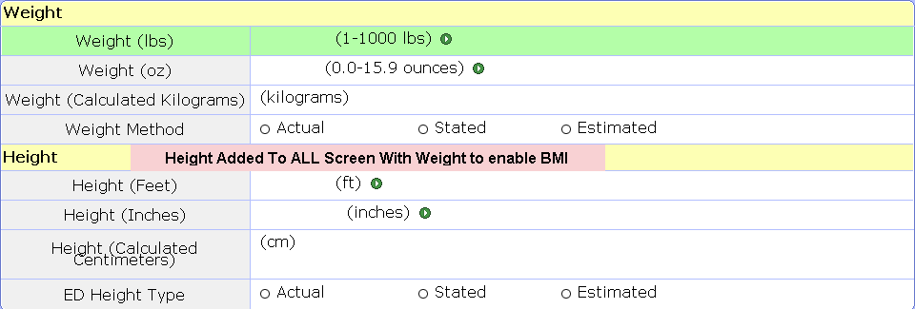

**Chief Complaint and Priority Added To Triage and Ambulance Screens**

The Chief Complaint and Priority have been added to the “Patient Presented to ED” Section which is found at the top of the Adult & Pediatric Triage Screens and near the middle of the Assessment after the “Pre-Hospital IV Therapy” section Adult & Pediatric Ambulance Screens.

**Note** – Filling in Chief Complaint and Priority here will send the Chief Complaint to Trackers

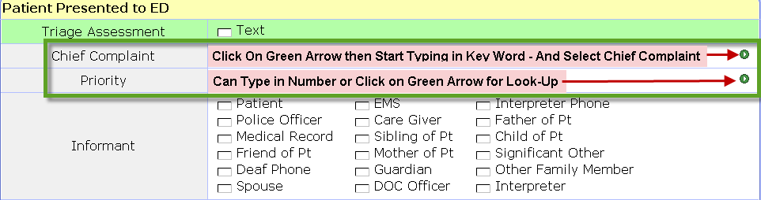

In addition, on the Adult & Pediatric Triage Screens, “Mechanism of Injury Present” has been added to the end of the “Patient Presented to ED” section

**Glasgow Scale Changes**

The following changes have been made on all screens with Glasgow Scale

1. The Scale will not Calculate until ALL required questions are answered
2. Once one question of scale is answered, you are required to answer ALL required questions
3. If you try to save without completing all required questions, you will get an error message.
4. When you click “OK” it will take you back to the question that was not answered.

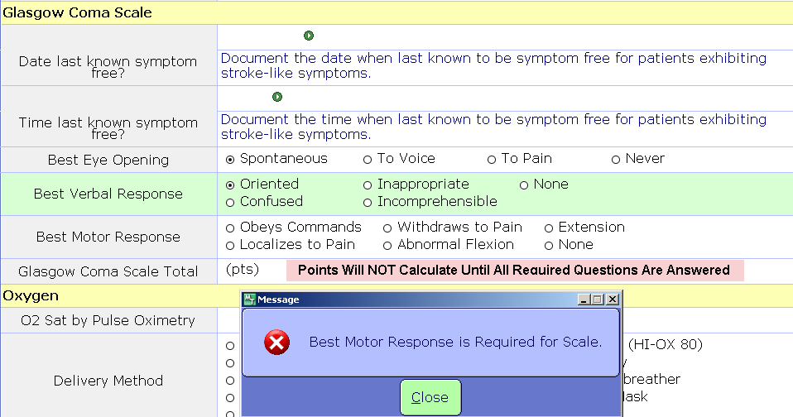

**Interventions affected are:**

ED Ambulance Triage Assessment

ED Pediatric Ambulance Triage

ED Triage Assessment

ED Pediatric Triage Assessment

ED Neurological Assessment

ED Neuro Checks (Order)

ED Trauma Assessment

ED Vital Signs/Monitor

|  |
| --- |
|  |

**Medication Indicator Enhancement**

The Medication Indicator will now turn Red if the Scheduled Medication is more than 20 minutes overdue.



**IV Therapy Screen Changes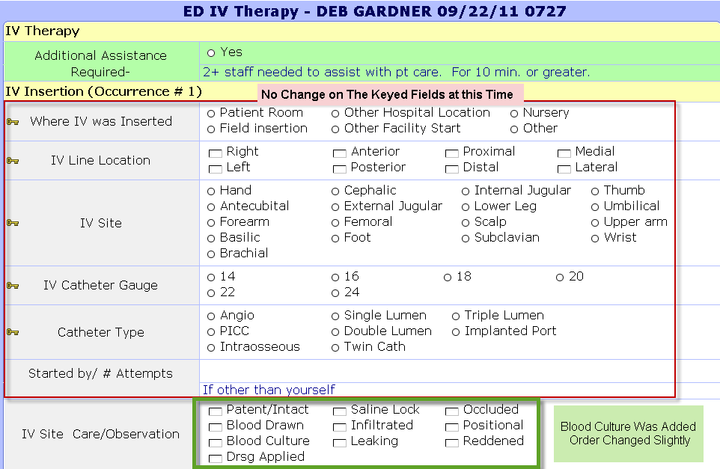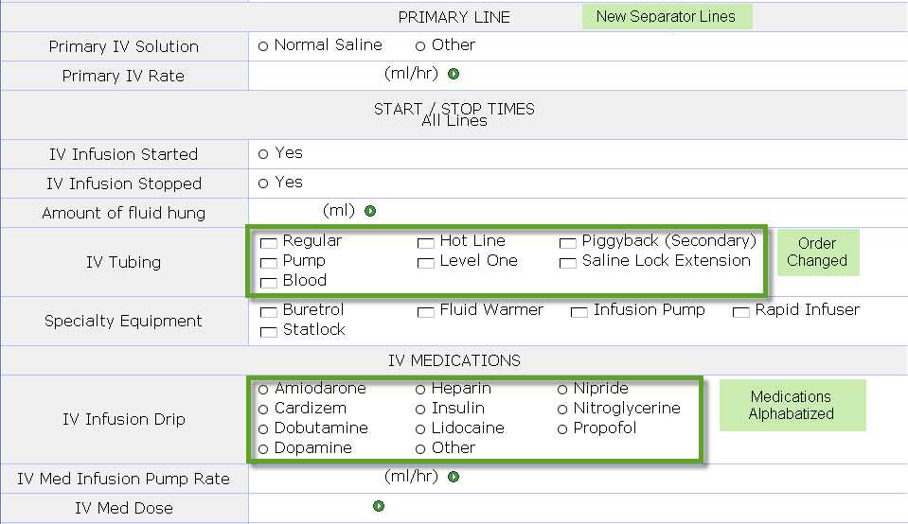**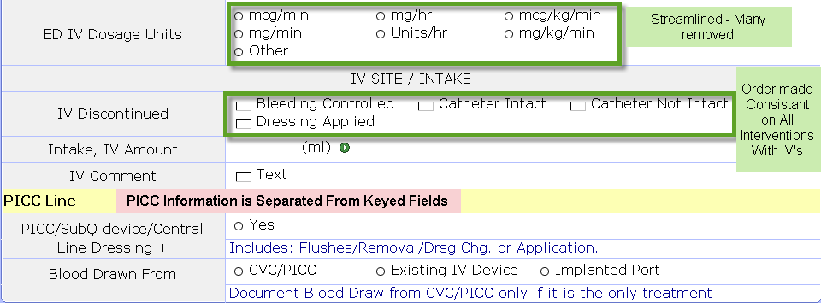

**The Following Changes IV Have Been Made:**

1. New Separator Lines
2. Blood Culture added to IV Site Care, Order Changed
3. IV Tubing – Order Changed
4. IV Infusion Drip – Medications Alphabetized
5. IV Dosages – Streamlined

**Changes have been made on the Following Screens, as appropriate,**

1. Ambulance Triage
2. Pediatric Ambulance Triage
3. Trauma Assessment
4. ED Admit Procedures
5. ED Transfer Out of Facility
6. Code Blue Record - IV
7. Patient Discharge