Providers:
When ordering medications that have a maximum amount of doses to dispense, please follow these steps:
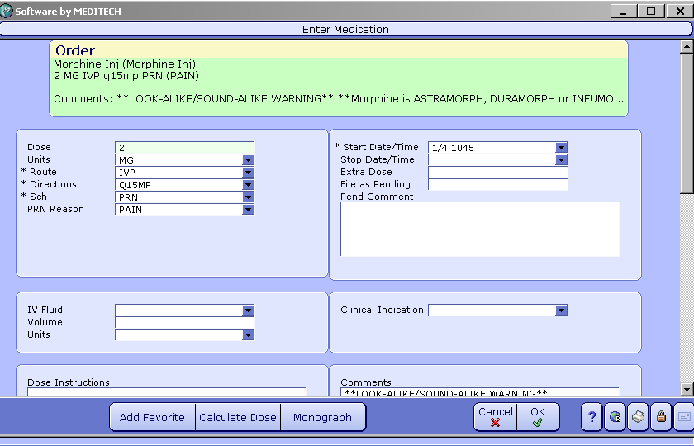
Select the appropriate dose and directions medication string. Click on the edit button and then select the stop date/time drop down menu.
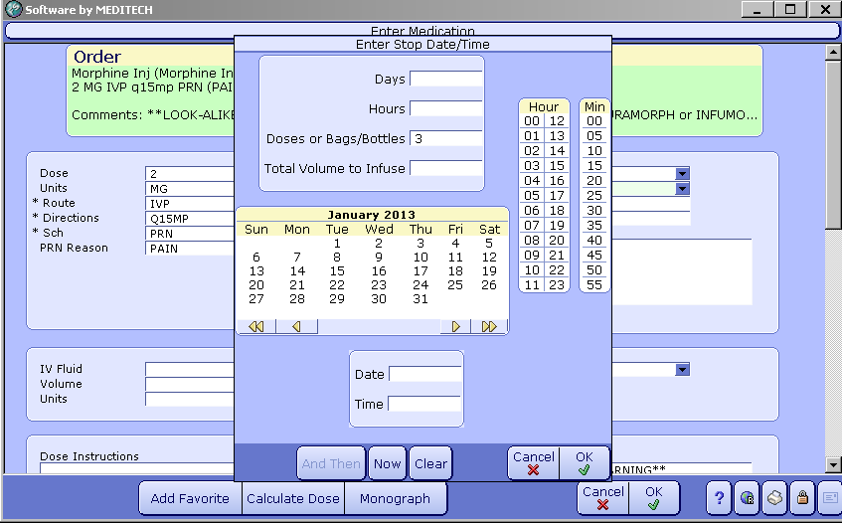
Enter the number of total doses to be administered. Select ok and then file the order.
Nurses: when documenting on the PRN doses with max doses defined, please follow these steps:

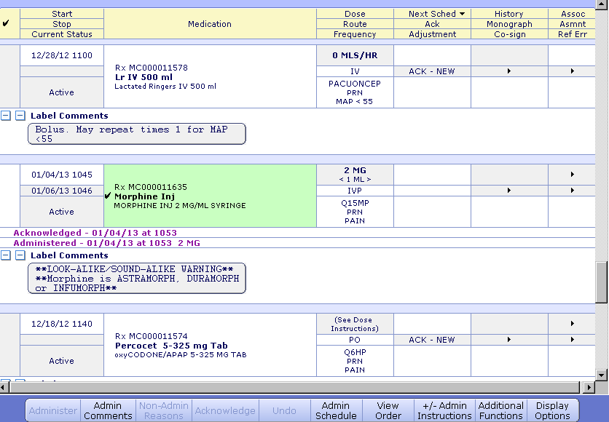
Acknowledge and administer the medication according to the directions ordered by the provider.

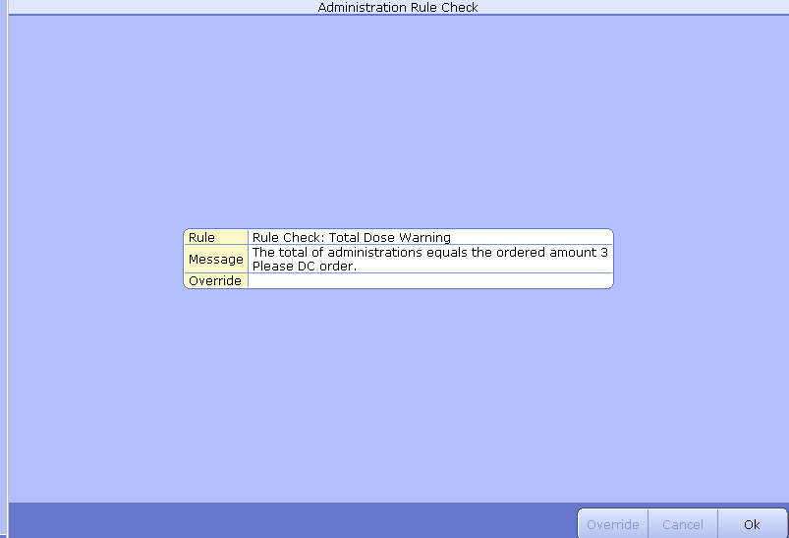
Once the max amount of doses has been administered, the nurse will receive this pop up warning. Click ok.

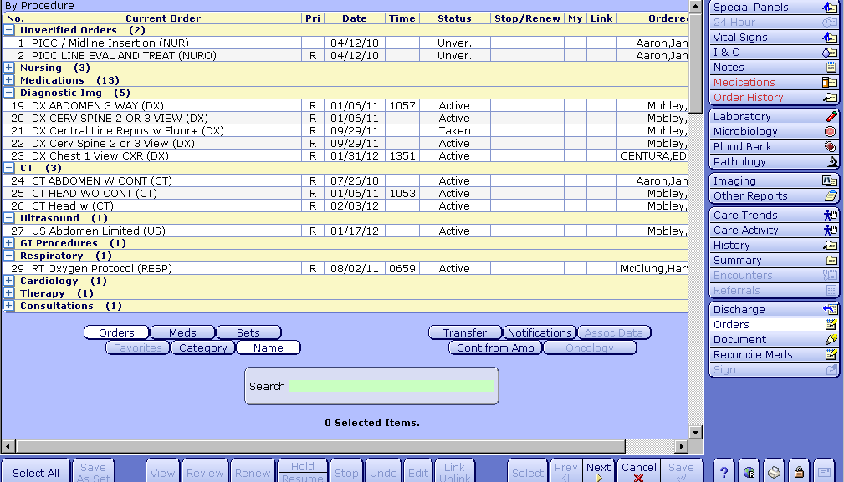
Access the EMR and select the proper patient. Via the “Orders” tab on the right, click on the + sign under the Medications tab.

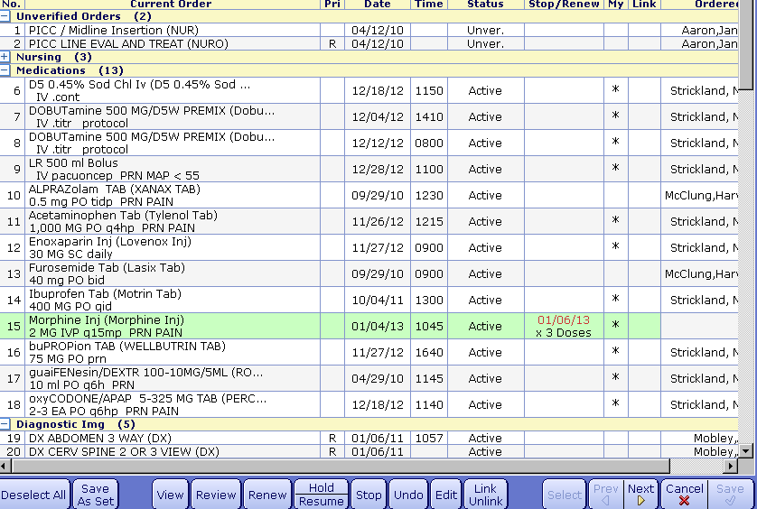
Highlight the proper medication and then select “Stop”

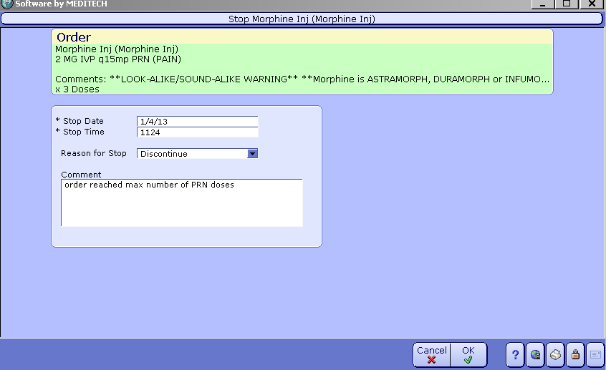
Select a reason for stop (Discontinue). Then enter a comment as stated here. Select OK.

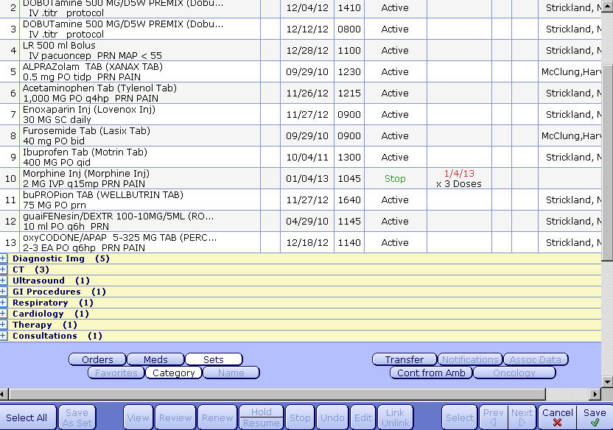
The order should now say “stop”. Click Save.

**ED nurses will access POM via the ED tracker rather than the EMR.
**Editing source should be “CPOE edit” when nurse is DC’ing the order.
**ED nurses will not be affected by this process change until the Universal eMAR is Live.

