# **EP35-10 St. Francis Medical Center Labor & Delivery Staff Meeting** May 23rd, 2012

# 

**j0250707 hcahps** March 2012 @ 97% for the top-box score! :o)

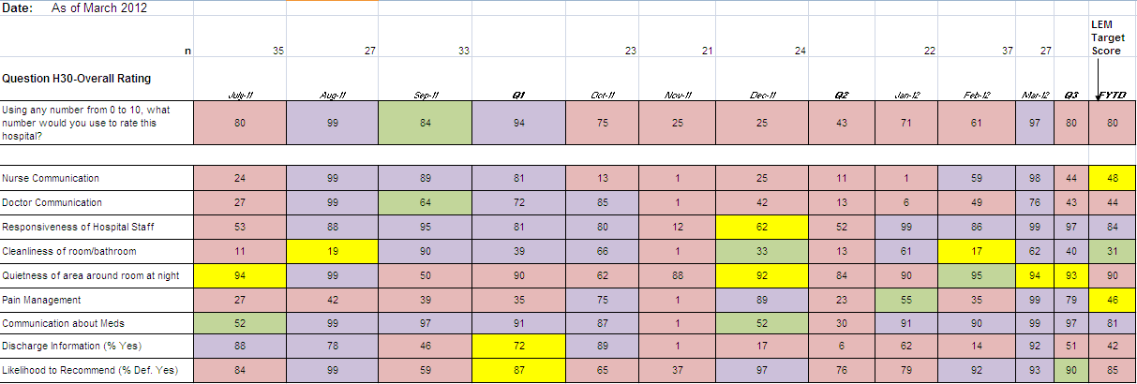

**j0250707 council/committee updates**

* + UPC-NPC Penrose is revising the dress code – piercings and visible tattoos are being looked at. Sybilla is looking for volunteers to help with handwashing audits. The system is also looking at all associates entering their vacation and other requests into AtStaff….more to come on this. Penrose is looking at doing peer evals again, and the question was asked about how we feel the “huddles” are going. Some staff reported that they feel that there are delays with everyone getting to the locker room, but mostly feel it’s good.
  + Quality- need new rep- once/month meeting for 1 hour to discuss hospital wide and unit specific quality indicators Please let Candace or Melody know if you are interested in being the Quality Rep.. It will count towards CAP
  + Triage - Charges, screen shots to help you remember what to charge for complicated IV situations We are finalizing these screen shots to provide guidance for these sometimes very confusing IV charges.
  + Mock Code Blue- Mock code blue done today 5/23
  + Transport- pressure point bracelets to help with nausea during transports
  + Sunshine- There will be a Sky Sox game and tailgate party the end of June, more to come.
  + Fetal Demise- The instructions for meditech pp discharge are in the front of the demise book

**j0250707 OR instruments**

* + Can you identify OR instruments? - Jeremy Eyman Presentation of the instruments done by Janny VanDusseldorp

**j0250707 protective eye wear**

* + PPE for deliveries- new eye shields

**j0250707 New hires- welcome**

* + Dee Jimenez, CST FT days- starting May 27th
  + Kerri Sherer, RN PD nights- starting June 18th
  + Stevie Perez, RN FT nights- starting July 9th
  + Openings: None

**j0250707 recognition**

* + - Seton winner for Clinical Excellence - Janny Van Dusseldorp
  + NCC-In patient OB: Kari Taylor

**j0250707 1st & Main**

* + L&D, NICU and Peds will all show off our services we provide at the June 8th First & Main Concert in the Park Looking for volunteer hours for CAP??? We need volunteers for this, please let Candace or Melody know if you are interested.

j0250707 **New payroll process for south state**

Linda Mathis South state payroll will now be handled in Denver, Linda will be putting out an email with the phone number

j0250707 **charges**

* + Don’t forget Delivery/Epidural charges- pass along in shift report if this still needs to be done
  + Sign in to the right unit in Meditech, we’re sending tons of charges to MB each day because we sign in to the wrong unit

**j0250707 telemetry process**

* + The teleox needs to be placed before you leave PACU- plan accordingly. It shouldn’t extend the length of your recovery
  + Call the tele tech when you get the unit in place before you leave PACU to give them your name and phone number
  + Process is on all WOWs in PACU

**j0250707 Service Recovery**

* + Gift certificates for patient service recovery- talk to your charge RN or Candace if you have a candidate. These are now kept in the charge office

**j0250707 Bedside shift report**

* + See attached