EP5 Bed Placement Office

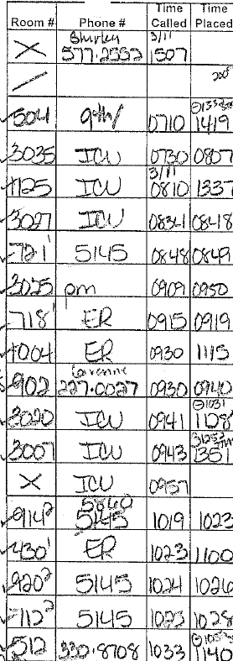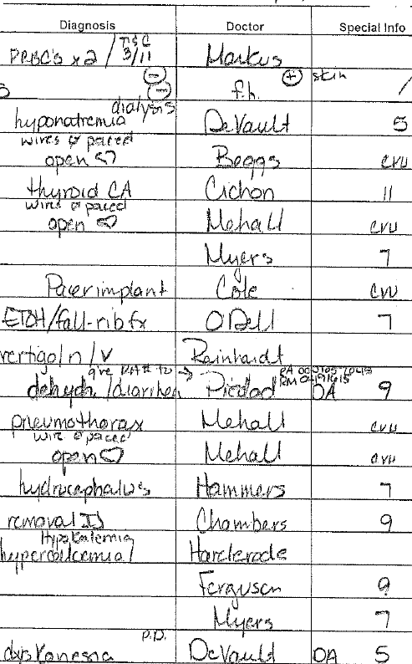

Standard of Care

Open Hearts go from OR to ICU to CVU

VRE isolation needs isolation room – none open on 5 so assigned to 10

