EP5-3 Wound Clinic – Treatment Inpatient and Referred to Outpatient Wound Clinic
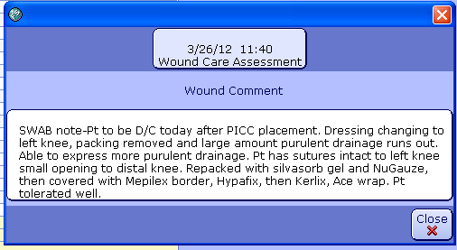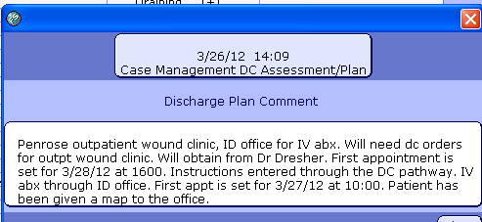
3/24/2012 Wound Clinic Assessment Notes refer to status and wound treatment when in hospital prior to discharge to outpatient Wound Clinic.
