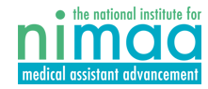
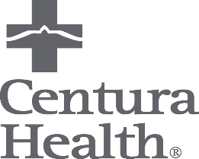

MA Apprenticeship Fact Sheet
September 2019
Centura Health Physician Group (CHPG) has partnered with the National Institute for Medical Assisting Advancement (NIMAA) to offer a 7-month course in medical assisting. The NIMAA program consists of a 100% online didactic and can be completed at various clinical sites throughout the State of Colorado. While going through the NIMAA MA Program, the student is hired at CHPG as a Medical Assistant Apprentice.
- Pay rate is $15.00/hour. The apprentice position does not offer benefits. Once apprentices transfer into Medical Assistant positions, they will be eligible for benefits through Centura Health. During the apprenticeship, the apprentice will function in a clinic support role performing duties such as vitals, rooming patients and various administrative tasks.

Program Cost:
The Tuition cost is $6,000. CHPG will pay for $2,500 of the tuition which will require a commitment agreement signed by the student to work with Centura Health for 13 months upon hires as a Medical Assistant after completing the program.
- The remaining $3,500 is the responsibility of the MA Apprentice and there are opportunities for tuition assistance through the Workforce Centers, Federal Student Aid and tuition reimbursement for Centura Health associates.
*Students hired at St. Thomas More affiliated clinics in Canon City will incur no out of pocket costs for the program (the $6,000 tuition will be fully paid).

Program Commitment:
The program is time intensive and requires a commitment from 30 to 60 hours per week.
- Minimum of 12 hours, up to 32 hours of working in the clinic Monday -Thursday
- Minimum of 10 hours of online education on nights and weekends (self-paced)

Application & Interview Process:
- All applicants must complete an application to the NIMAA program – see additional information and steps to apply at www.nimaa.org
- Students must pay a non-refundable $25 application fee and submit their applications by July 15th.

Employment at Centura Health:
- The first day of the NIMAA cohort is Tuesday, September 3rd. All offers of acceptance and employment will be extended and must be accepted by August 15th.
- For apprentices without an active BLS (Basic Life Support) from the American Heart Association, certification will be required within 90 days of employment. Training will be offered via Edcor during orientation.
- Upon completion of the program, students will be eligible to test for certification and consideration for current Medical Assistant roles.

