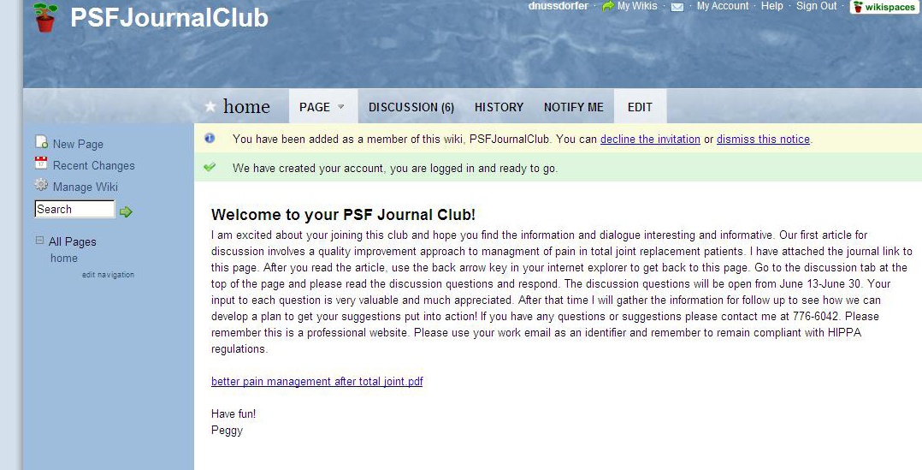

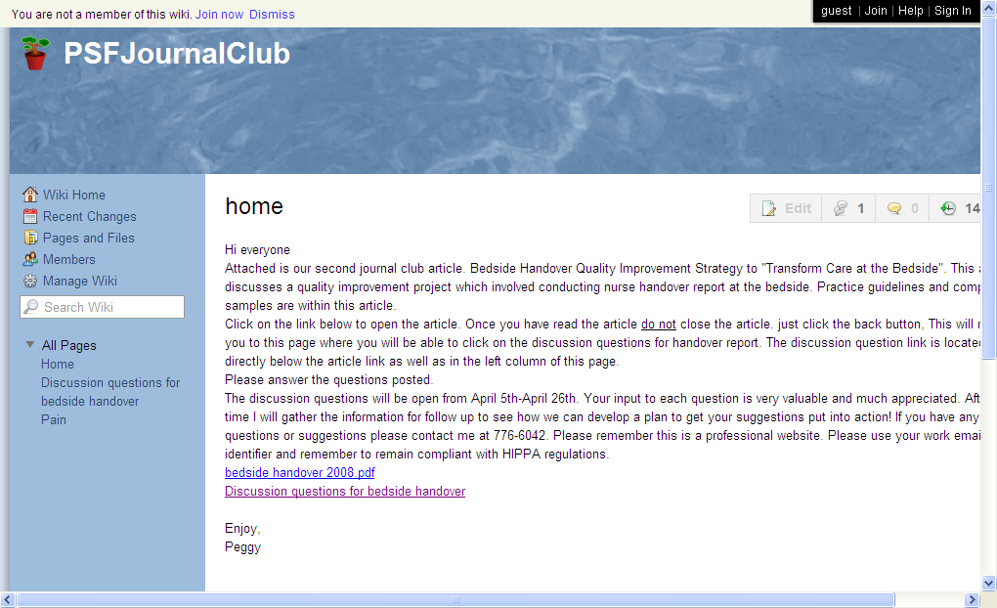

From: Plylar, Peggy
Sent: Thursday, April 05, 2012 12:33 PM
To: Bartley, Susan; Birmingham, Tracie; Blane, Jaime; Breedlove, Lori; Bruce, Janine; Calvert, Lizbeth A; Chandler, Sondra; Clark, Sarah C; Cline, JeriAnn A; Dipalma, Jessica; Frymire, Therese J; Goldberg, Alison; Hall, Susanne; Johnson, Carlos L; Kaufman, Elizabeth; Mason, Nicole; Nichols, Earnestine W; Nussdorfer, Debra; Oliver, Kristine; Reser, Lauren; Rice, Chelsey; Sampson, Camilla; Simmons, Freeman M; Simpson, Audrey; Smith, Elizabeth; Smoliak, Gloria H; Ward, Cheryl; Williams, Kristine; Yi, Yun hui
Cc: Moore, Rose Ann; McCord, Kate
Subject: You are invited to participate in a journal club discussion!
Hi everyone
Our second journal club article has been posted to our wikispace. This journal article is related to bedside handoff report. Just click on the below link to get started. Remember to sign in if you are already a member and have participated on this site. If you are new, please join us. Both the article and the discussion question links are on the homepage. I would like to have all discussions completed by April 26th. I appreciate and look forward to a lively discussion.
http://psfjournalclub.wikispaces.com/

