NK5-6 Approval by CNO for conference attendance and funding
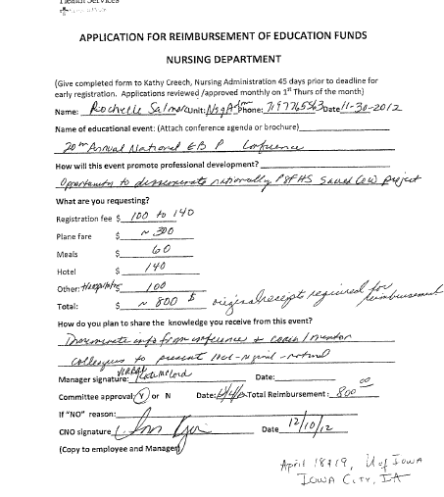
Application asks for plans on disseminating knowledge gained at conference.

