NK7- 11 Meditech Update
Urinary Catheter Insertion, Care and Removal
Date of Implementation: 3/13/12
Modules Affected: PCS, ORM, EDM
Here’s why: The Adult Acute Care CAUTI Prevention EBP Team (Catheter Associated Urinary Tract Infection) has
3 main goals:
- Reduce CAUTI rate per 1000 urinary catheter days
- SCIP Goal Remove urinary catheter by Post Op Day 2
- Reduce urinary catheter days
In order to support these goals, the Meditech documentation has been integrated to utilize the same queries in all modules. This will assist in clear, accurate documentation of urinary catheter insertion, care, removal and support data collection to demonstrate care delivered.

Screen changes impacting EDM:

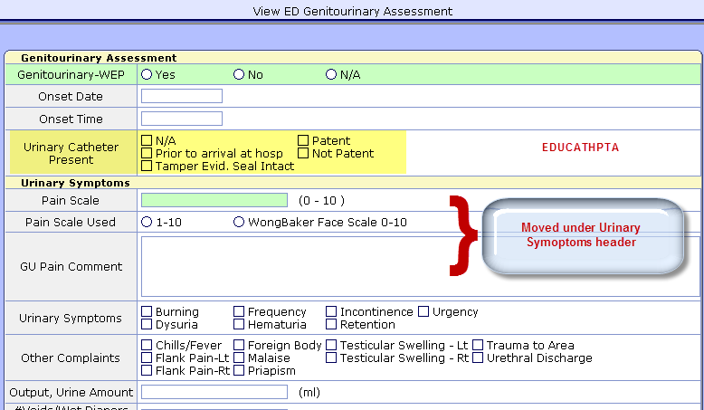
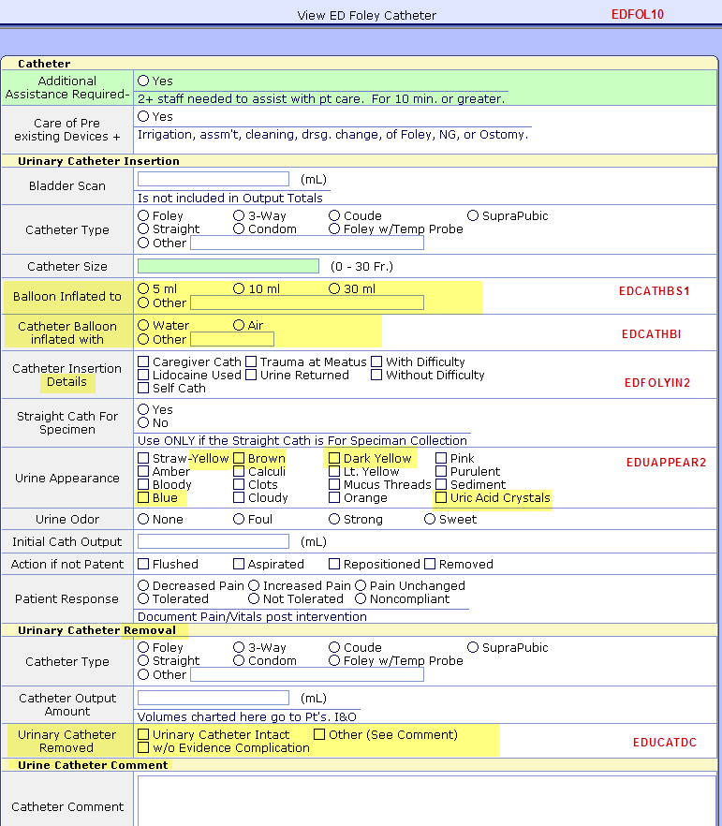

Screen changes impacting ORM:
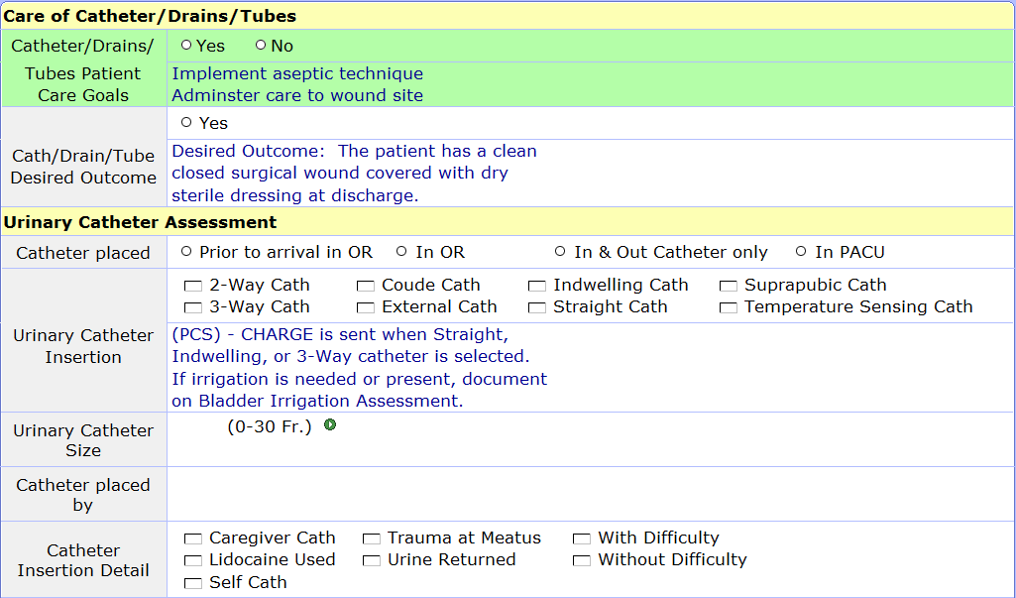

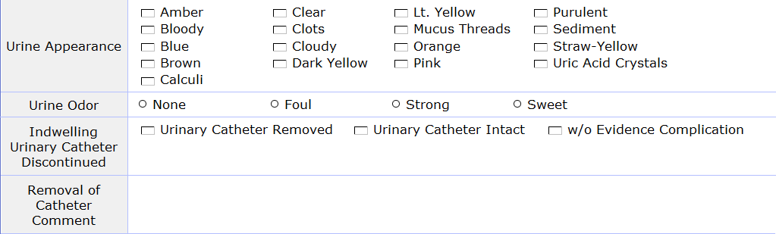

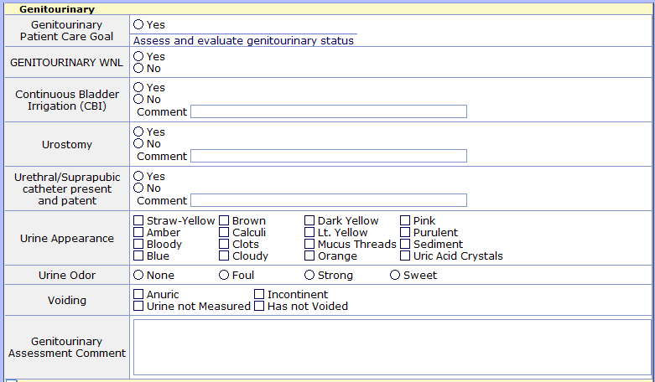

Screen changes impacting PCS:

Gen Admit Data – in all specialties (including OB, Pediatrics, Hospice)
Important to note if catheter present on arrival and if tamper evident seal intact

In PCS, Urinary Catheter Insert and Urinary Cath Removal Interventions will go to work list from order entry in POM. When complete, the status of these assessments can be changed to complete.

