NK7EO-12 Pt Education Information



**Pressure Ulcer Prevention**

**What are pressure ulcers?**

Pressure ulcers, also called bedsores, are injuries to the skin or the fatty tissue under the skin caused by pressure or friction.

**What causes them?**

When parts of the body are pressed against the bed, chair, each other or any object for

a long period of time, the tissue may not get enough blood or oxygen. If the pressure is

unrelieved, the tissue can be damaged and a pressure ulcer can form. Skin can also be

damaged when it is rubbed against an object, even for as short as twenty minutes.

**Where do they appear?**

Pressure ulcers usually form on bony areas of the body like heels, elbows, shoulders and the tailbone. See dots for possible areas.

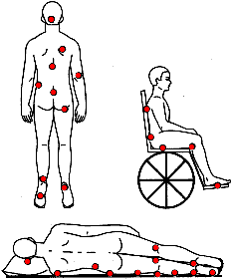

**Why am I at risk? What can I do?**

Your risk factors may include:

* Age
* Limited ability to move
* Incontinence (leaking) of urine or stool
* Reduced sensitivity to pain or discomfort
* Damp skin from perspiration or a wound
* Poor circulation
* Eating or drinking poorly
* Previous pressure ulcers
* Fragile skin

**What if I have Questions?**

Ask your health care provider.

* Check your skin every day for

purplish/bluish, or red patches

swelling, blisters, irritated areas, cracks, sore areas.

* Keep skin dry and clean.
* Prevent dry skin by using creams or oils.
* Decrease exposure to urine, stool, perspiration or wound drainage.
* Change position at least every two hours while in bed.
* Use pillows between knees and ankles.
* Shift weight every 15 minutes while seated.
* Eat a balanced diet.
* Drink plenty of fluids.