When the medication name is known but the dose and/or frequency is unknown:
- In AOM /Reconcile Med screen: Enter name of medication, select lowest strength available
- Checkmark “zero dose string” if available or edit string to dose of 0 and <freq> UNKNOWN )
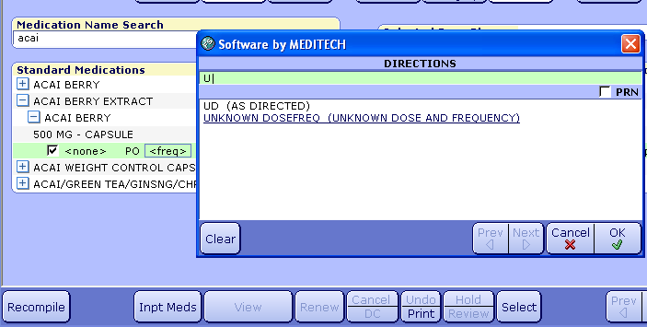

- Click “Select” button. (on bottom toolbar) “Last Taken” screen appears.
- Checkmark “Unknown Dose” (and/or Unknown Date/Time -if applicable) - Save.
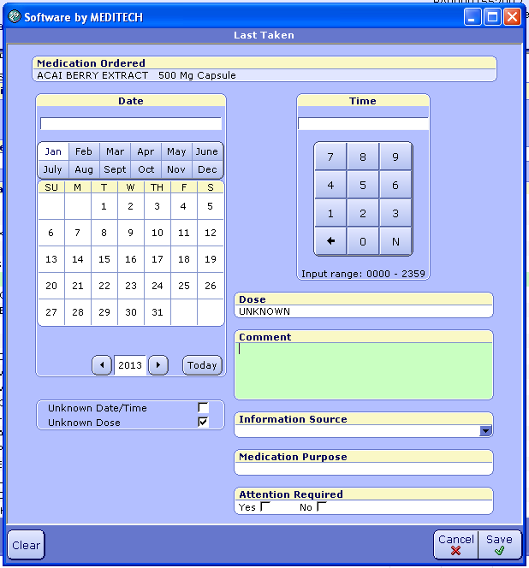

Result:
Unknown Date
of last dose

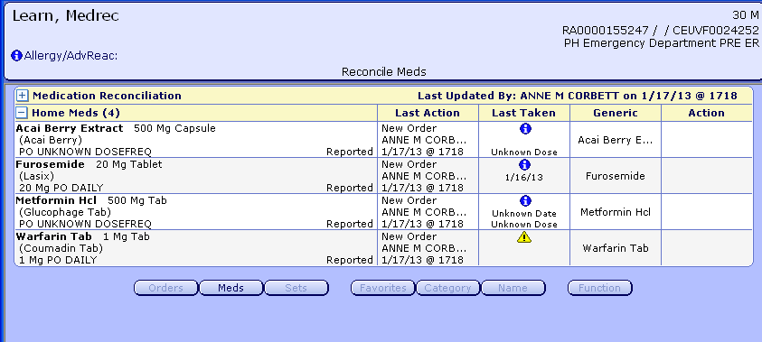
“Unknown Dose” displays here

“Attention Required”
Click to read comments

