SE 3 Clinical Advancement Award Levels

PSFHS PROFESSIONAL RN CLINICAL ADVANCEMENT PROGRAM (CAP)
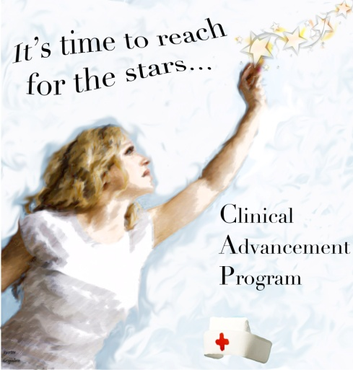
Highlighted Yellow demonstrates CAP requirements
CAP AWARD LEVELS

CAP I Award $1,000
Must have a minimum score of 10 points on the application component.
Must have a minimum score of 25 points on each of the behavioral evaluations and all ratings must be 3 or above.
Must write one Clinical Narrative/Exemplar.

CAP II Award $1,800
Must have a minimum score of 12 points on the application component.
Must have a minimum score of 25 points on each of the behavioral evaluations and all ratings must be 3 or above.
Must write one Clinical Narrative/Exemplar.
Must be a participant on a Committee that is recognized by the CAP PEER REVIEW BOARD for at least 6 months prior to Dec 30
Must have BSN OR National Nursing Certification

CAP III Award $2,500
Must have a minimum score of 14 points on the application component.
Must have a minimum score of 28 points on each of the behavioral evaluations and all ratings must be 3 or above.
Must write one Clinical Narratives/Exemplar.
Must be a participant or chair on two Committees that are recognized by CAP PEER REVIEW BOARD
Must have a minimum of BSN and National Nursing Certification OR Master’s Degree in Nursing.

