TL4-7 Changes to the “Teach CHF” Intervention

- 3 minor changes have been made to this intervention, based on necessity of meeting the mandatory Core Measure for Heart Failure.
  - Intervention name changed from “Teach CHF” to “Teach HF”
  - Highlighted field now has a single checkbox to indicate that one of 3 acceptable forms of written HF instructions was given:
    - “Understanding HF” color, double-sided handout
    - “Heart Failure – Patient Self-Care Workbook” – color, 16-page booklet
    - “Discharge Care” – CHF in Micromedex – black/white, 4 pages
  - The highlighted area is the critical section that meets the core measure. If it is checked, we meet the measure. Staff should either (1) provide the written HF instructions as described in #2 above, OR (2) determine that written HF instructions were already given to the patient (by looking at previous documentation OR by asking the patient).
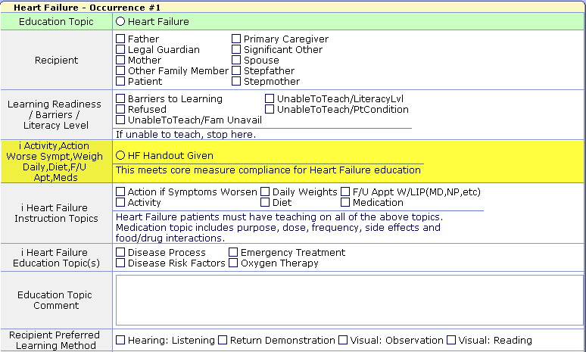

- Provision of the written HF instruction material need only occur once during the hospitalization, and that is what is being documented in this field. Verbal reiteration of the content on the written HF instructions should occur throughout the hospitalization.

