The Daffodil Award is used to recognize exceptional, caring staff who go above and beyond what is required of them. There are several awards that can be given to the staff. The daffodil award focuses on certified nursing assistants, certified surgical techs, unit secretaries, and telemetry techs.

C:\Documents and Settings\meditechws\Local Settings\Temporary Internet Files\Content.IE5\ZOO258KL\MC900331608[1].wmf

To nominate a staff member please share your story and name inside this brochure and give to a clinical manager or the charge nurse.

**DAFFODIL Certified Nurses Assistants/Certified Surgical Techs/Unit Secretaries/Telemetry Techs**

Are nominated by patients, families, colleagues, physicians, and others. The nomination tells a story of compassionate, memorable and expert care.

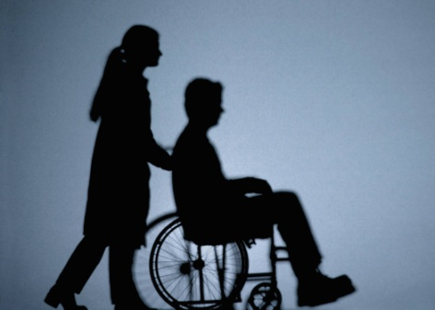

**DAFFODIL CANDIDATES**

* Focus on meeting patient and family needs
* Provide relationship based care through respectful, positive communication
* Create a positive environment
* Lead with flexibility and integrity
* Value each patient’s life by lovingly offering care to all people
* Provide a compassionate and caring touch to the whole person – body, mind and spirit

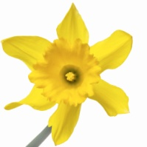

**The**

**DAFFODIL**

**AWARD**

**Would you like to give special recognition to a Certified Nursing Assistant/Certified Surgical Tech/Unit Secretary/Telemetry Tech?**

“I wanna do something that matters, say something different. Something that sets the whole world on it’s ear. I want to do something better with my time, and I want to try to touch a few **hearts** in this life. Leave nothing less than something that says ‘I Was Here’”

“You treat a disease: you win, you lose. You treat a person, I guarantee you win. No matter the outcome.”

~Anonymous

**­­**

**PLEASE SHARE YOUR NAME, THE NAME OF THE STAFF AND YOUR STORY HERE! THANK YOU FOR RECOGNISING THE HEART, MIND AND SPIRIT OF OUR STAFF!**

**C:\Documents and Settings\meditechws\Local Settings\Temporary Internet Files\Content.IE5\P2UATDTZ\MC900023345[1].wmf**